**Azure Subscription capacity (quota) management**

To verify the usage and quota, Search for each subscription and open it.

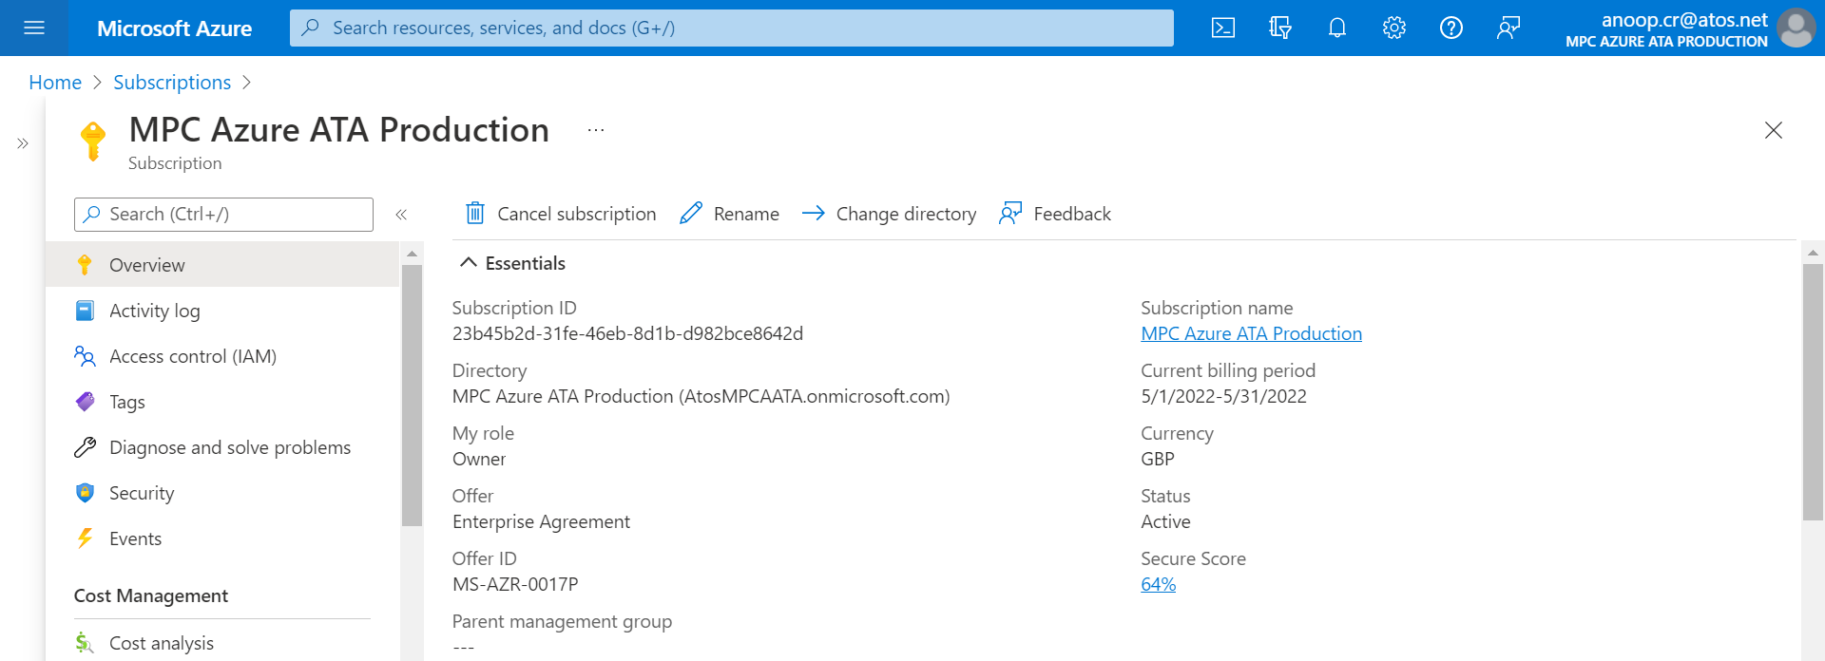

2. Open Usage + quotas from left pane.

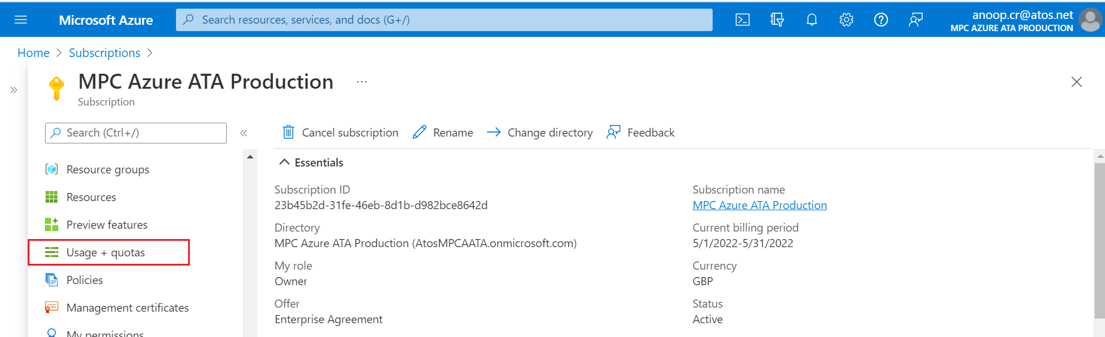

3. Verify the current usage of each item. It will sow current quota limit and actual usage.

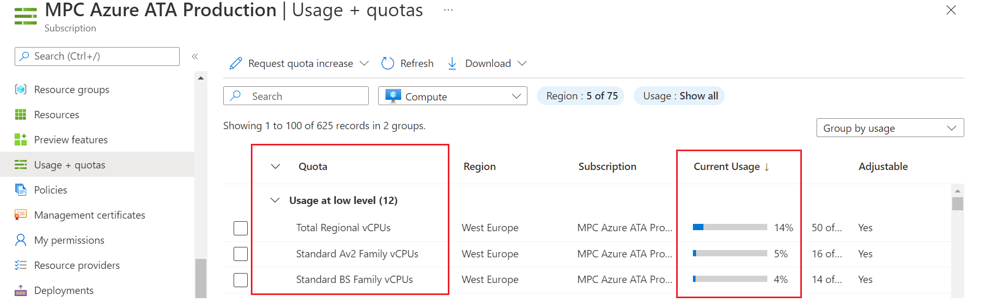

5. Usage can be verified for multiple resource categories.

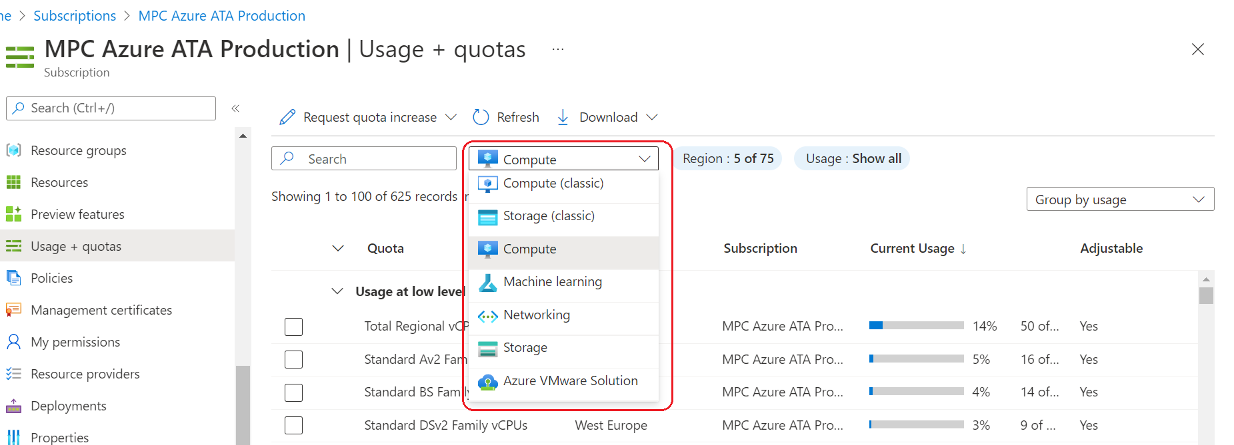

6. If any quota is showing as Adjustable as Yes, that can be increased online using “Request quota increase” option. For others, a support request needs to be raised for the increase.

